SYSTEMS AND SITES RELIABILITY ENGINEER HOMEWORK

### Simple Web Application

Nodes:
- Controller Node
- Hostname : control-station. aulialabs.com
- IP Address : 192.168.230.128
- User : ansible
- Managed Node (as Webserver)
- Hostname : webserver.aulialabs.com
- IP Address : 192.168.230.131
- User : ansible

Controller Node
IP address:
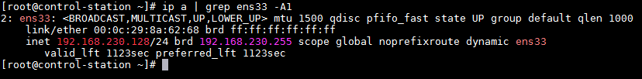
Hostname:
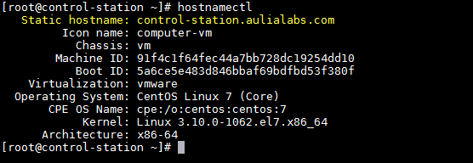

Managed Node (Webserver)
IP address:
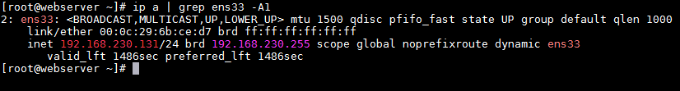
Hostname:
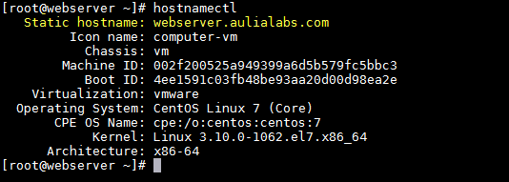
Prerequisite Tasks:
- Ansible package and it dependencies already installed on Controller Node
- Connection to the managed node should be passwordless
- This task will be executed by the user "ansible"
On the Controller Node
- Create user “ansible”
# useradd ansible
# passwd ansible
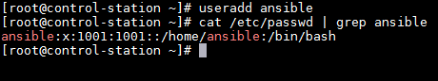
- Grant user “ansible” as sudoers
# vim /etc/sudoers.d/ansible
ansible ALL=(ALL) NOPASSWD:ALL
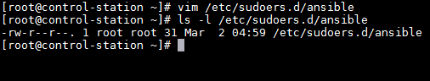
- Setup SSH passwordless as user “ansible”
# su ansible
$ ssh-keygen
$ ssh-copy-id localhost
$ ssh-copy-id
On the Managed Node
- Create user “ansible”
# useradd ansible
# passwd ansible
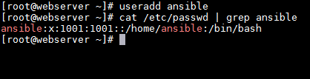
- Grant user “ansible” as sudoers
# vim /etc/sudoers.d/ansible
ansible ALL=(ALL) NOPASSWD:ALL
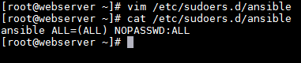
- Setup SSH passwordless
# su ansible
$ ssh-keygen
$ ssh-copy-id localhost
$ ssh-copy-id
Setup the Web Server
- Create an inventory file at /home/ansible/inventory
$ vi /home/ansible/inventory
[control]
control-station.aulialabs.com
[webserver]
webserver.aulialabs.com

- Test ping to All nodes (Controler & Managed Node) from Controller Node to ensure the connection successfully established.
$ ansible -i /home/ansible/inventory -m ping all
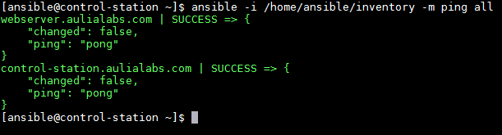

- Create a Jinja2 template file index.html.j2 is used to create the file /webserver/index.html
$ vi index.html.j2
The IP address of ‘{{ ansible_hostname }}’ server is: ‘{{
ansible_default_ipv4.address }}’
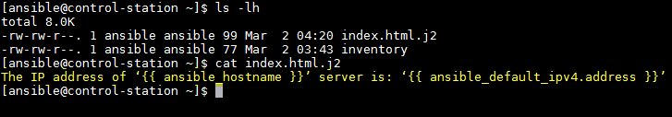
- Creating a playbook /home/ansible/webapp.yaml that runs on webserver node.
$ vi /home/ansible/webapp.yaml

---
- hosts: webserver
become: yes
vars:
webdir: /webserver
web_linked: /var/www/html/webserver
pkgs: httpd, firewalld, mod_ssl
jinja2_temp: index.html.j2
all_svc:
- httpd
- firewalld
tasks:
- name: Install all packages needed
yum :
name: "{{ pkgs }}"
state: latest

- name: Enable and start the all service needed
service:
name: "{{ item }}"
state: started
enabled: yes
loop: "{{ all_svc }}"

- name: Allow all port needed for services to communicate
firewalld:
port: "{{ item }}"
immediate: true
permanent: true
state: enabled
loop:
- 80/tcp
- 443/tcp

- name : Create a web directory
file:
state: directory
dest: "{{ webdir }}"
owner: apache
group: apache
mode: u=rwx,g=rx,o=rx

- name: Install jinja2 template for a web content
template:
src: "{{ jinja2_temp }}"
dest: "{{ webdir }}/index.html"
owner: apache
group: apache
mode: u=rwx,g=rx,o=rx

- name : Create symbolically linked from {{ webdir }} to {{ web_linked }}
file:
src: "{{ webdir }}"
dest: "{{ web_linked }}"
state: link

- name: Set a selinux permission to {{ webdir }} and {{ web_linked }}
sefcontext:
target: "{{ item }}"
setype: httpd_sys_content_t
state: present
with_items:
- "{{ web_linked }}(/.*)?"
- "{{ webdir }}(/.*)?"

- name: Re-write the selinux permission to {{ webdir }} and {{ web_linked }}
command: "{{ item }}"
loop:
- "restorecon -vvRF {{ webdir }}"
- "restorecon -vvRF {{ web_linked }}"
notify: restart httpd

handlers:
- name: restart httpd
service:
name: httpd
state: restarted
...
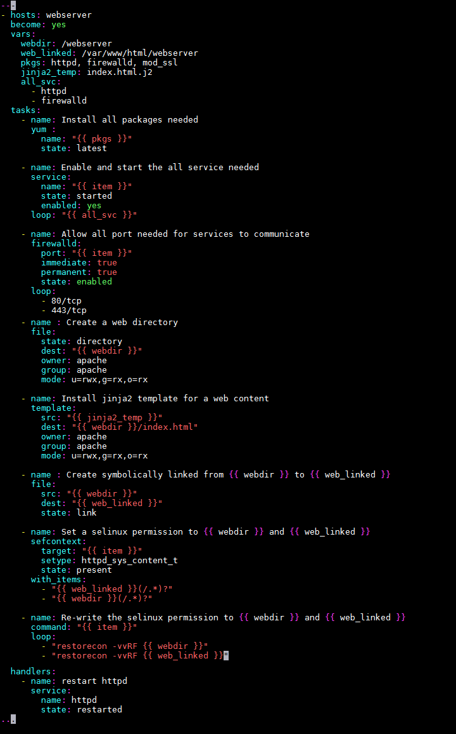
- Run playbook /home/ansible/webapp.yaml
$ ansible-playbook -i /home/ansible/inventory /home/ansible/webapp.yaml
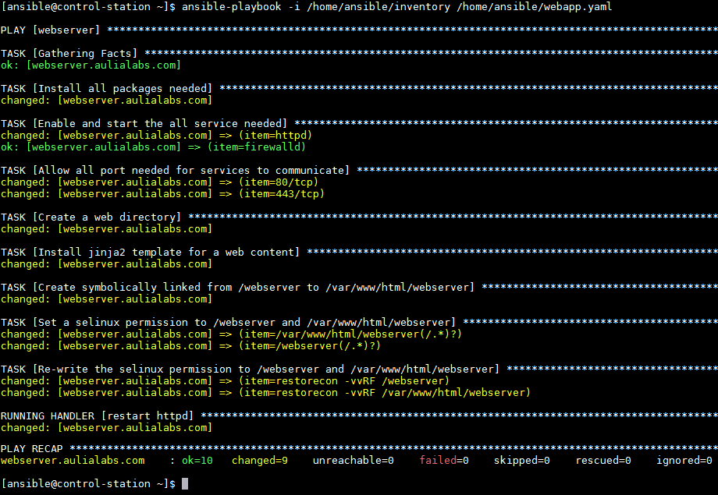
Here is the result after running the playbook:
